PACS Mobile Best Practices
Note: this document is designed to be complimentary with the PACS Appraiser Field Orientation Guide.

Table of Contents
Pre-Enter Data 2
Improvements/Details/Features 2
Sketching 2
Lync Practices 2
Field Practices 3
Email 3
Downloading/Refreshing 3
Pictures 4
Notes 4
Marking Complete 4
Copying New Construction 4
Soft/Hard Rejects 4
New Construction Value 4
Back in Office Practices 8

Last Update 5/19/17 cmp

Pre-Enter Data
As PACS Mobile is designed to be used as a data collection tool, we can maximize our field time by pre-entering as much data as possible before entering the field. Then, we will only need to verify additions and changes, as opposed to making them while we’re out of the office. This includes sketches, as well as improvements, details, and features.

Improvements/Details/Features
All Improvements and Details should be entered on the property before fielding it. Changes can be made in the field, but the basics need to be entered before you leave. This is also true for features.
When prepping a parcel, utilize the reference property, PID 307443, and copy the appropriate Improvements and Details to your parcel. This will also automatically add the default features that need to be added and verified in the field.

Sketching
Sketches that were converted from ProVal have various errors that cause issues while in the field. The only viable solution is to delete them in their entirety and rebuild them from scratch. The best way to do this is to recreate the sketch in PACS prior to fielding the property, as trying to modify the converted sketch from within Mobile is difficult.
Get into the habit of double checking the accuracy of your permit’s sketches and updating them before leaving the office. However, there is always the chance that this can be overlooked. In the event a sketch was not checked and is causing issues in the field, the simplest solution is to delete it. Rather than sketching the property again in the field, delete the sketch and sketch only the portion that you are adding to the record. Once you’re back in the field, you can recreate the sketch from the image of the ProVal sketch that is saved and attach your new construction to it.
Finally, make sure PACS Mobile is running and functioning correctly before leaving the office. This includes performing a hard reboot of your iPad by holding down the home screen and power button until the Apple logo appears on the screen. Get into the habit of doing this weekly on your first day back into the office.

Lync Practices
Before going out into the field, write ‘In Field – New Construction’ into the “What’s happening today?” box.
Change your status to ‘Busy’.
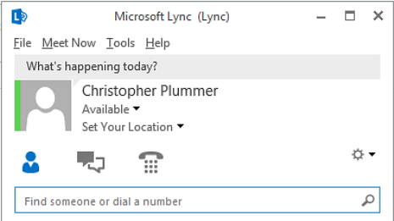
CTRL-ALT-DEL to lock your computer.
These steps are crucial in making sure that the rest of the staff knows where we are at any given time.

Field Practices
Always be sure to knock on doors and make yourself visible to the taxpayers.
Practice safety. If a fence is locked, a dog is present, or you do not feel comfortable on a property, excuse yourself. If a taxpayer asks you to leave, leave and note it.
If only a minor is at home, leave your card and ask to have the owners of the property call you back to arrange a time to appraise when they are present, or when no one is at home.
Be sure to have a handful of Chris’ business cards on hand as well, in case a taxpayer wants your supervisor’s information.
Do not leave your iPad in your car during your breaks. Not only are they expensive targets for theft, but a hot car interior can damage it.

Email
We all have our email accounts set up on our iPads. This will be our primary method of communication between each other in the field. Make sure to check them. Remember that our email accounts are public record.

Downloading/Refreshing
Download/Refresh your assignment groups when you are in the area. PACS Mobile assigns priority to parcels geographically. This is especially important during Reval, when we will have hundreds of parcels in each assignment group. PACS Mobile can only make a portion of them accessible at a time and a refresh in the area you’re working will ensure that you’re getting the proper parcels for the area you are currently fielding.

Pictures
Remember, turn the iPad sideways with the home button to the right. Avoid pictures that have taxpayers in them. If you need to take multiple pictures to include other structures, please do so. Be sure to take pictures of any bare land parcels as well.

Notes
Notes will be entered into Events, under the Appraiser Field Notes designation (which is the only option available to us on mobile). Remember, if the Event already exists, do not create a new one. Add to it on the top. This way, the newest notes will always be first in the Event.
Our notes can be more in-depth and detailed. A good example of this is measuring a property. If a home was not 100% complete and you relied on the previous appraiser’s measurements, you can add that you “did not measure” the property. Similarly, if you measured the home, write that you did so.

Marking Complete
It is important to mark a parcel complete on site once you are finished with it. Not only does this create a stamp of your activity and presence on site, but it uploads to the cloud which allows Chris to review it. If something needs to be checked again, it’s better to already be in the area when it is rejected for another pass.

Copying New Construction
When working new construction properties, the copy improvement task will allow the appraiser to copy information from a property with the same, or similar floor plan to the subject property.

Soft/Hard Rejects
A soft reject means that something regarding the data that has been entered by the appraiser needs another look. Chris will also note in your ‘Alert from Office’ field what should be given another pass. Soft rejecting a parcel does not undo the changes the appraiser has made, it only makes it visible for that appraiser to make changes. Once a soft reject has been addressed by the appraiser, it needs to be marked as complete again.
A hard reject removes all changes that an appraiser has made and puts the parcel back to square one. The best use for this is in the event of a catastrophic error on the appraiser’s part. If an appraiser inadvertently deletes an improvement, changes data incorrectly, or just overall messes up his or her field work, he or she can mark the property as complete and add an alert from the field that says “Do not approve. Hard reject so I can start over.” This will put the appraiser back to square one to try again.
Please do not ask for a hard reject on small errors, but remember that the option is available in the event of multiple erroneous changes.

New Construction Value
When adding new construction in PACS Mobile, we need to follow some steps to make sure the value is distributed properly in PACS.
At the Improvement level, we will need to select the new value type:
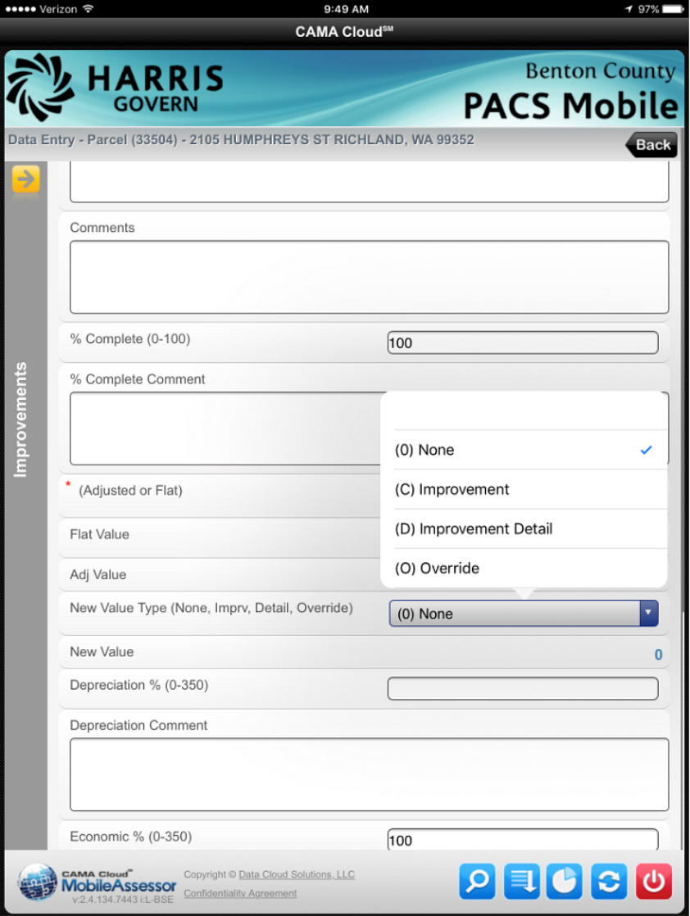
If you’re picking up a new home, the new value will be coming from the Improvement level. If it’s a detail, like an addition, covered patio, pool, etc, the new value will be coming from the Improvement Detail level.
Then, within the Details, make sure you are selecting ‘True’ from the New Value drop down for each New Construction segment you are creating:
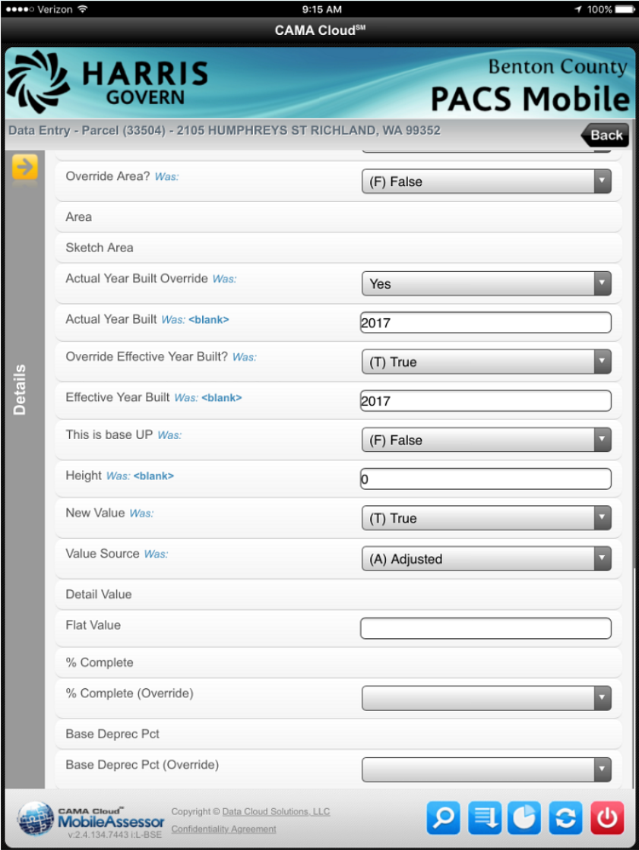
This tells PACS which value will be added as New Construction value.
And this is how it looks in PACS:
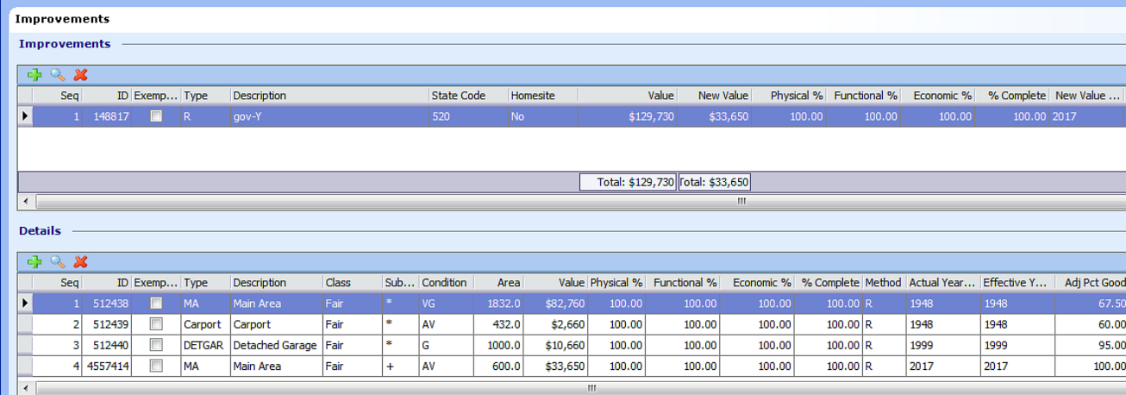
Further digging into the various levels, at the Detail level:
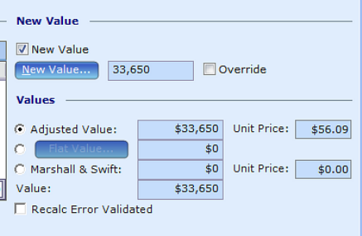
And at the Improvement level:
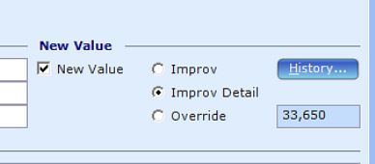

Finally, at the Value screen:
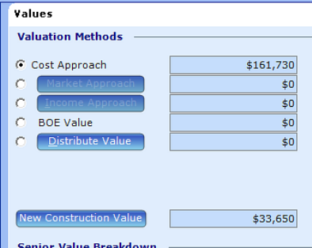
This tells us that of the overall value of the property, $33,650 will be New Construction for the 2017/2018 tax year.

Back in Office Practices
After Chris approves changes, it takes approximately 15 minutes for them to show up in PACS. Not only that, but unapproved changes do not transfer over. If you see a discrepancy between what you changed and what shows up in PACS once you’re back in the field make sure the field work was approved and that a proper amount of time has passed. Failure to follow these guidelines will result in data collision errors and could wipe out your data.
This also means if you check a property and see that it has not updated and close out of the property do not save, even if you have not made any changes.
Make sure all of your New Construction values are set to New Value.

